Cognizant 2.0
Cognizant 2.0 is a combination of Delivery and Knowledge Management.
It is an end to end integrated global delivery ecosystem which connects Cognizant , Clients and vendors on a single Platform.
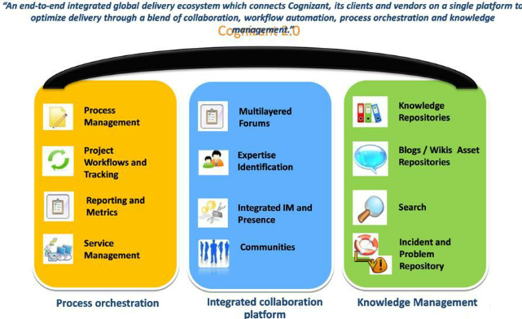
C2.0 Home Page
Mash up page is the landing page of Cognizant 2.0
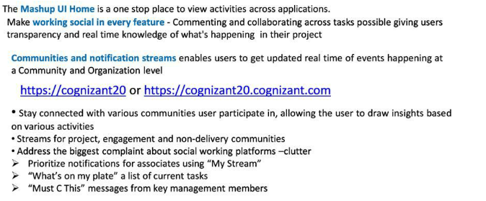
- Public Stream will have the Blogs, Cweet posted by all the resources from Cognizant All dl.
- My Stream will have the Blogs, Cweet, Q&A, Documents posted by you.
- Community Stream will have the Blogs, Cweet, Q&A, Documents posted in the community in which you belong to.
- Network Stream will have the Blogs, Cweet ,Q& A, Documents posted by the resources whom you follow or resources who follow you.
C2 Process space: C2→Home→Processes
- Process space has details of process package includes a number of phases which are divided into activities and tasks. You can view a description of the process package, its work breakdown structure, process disciplines, various roles involved, and the tasks that each role needs to perform. Process space has details of process package includes a number of phases which are divided into activities and tasks. You can view a description of the process package, its work breakdown structure, process disciplines, various roles involved, and the tasks that each role needs to perform.
- You can view details of the work products, guidelines, and checklists of either the selected process package, or a specific task in the selected process package.
- You can also view the tailoring guideline, testing, and review tasks in this process package, the glossary of terms used, and the change history of the selected process package.
- The Benchmark values can be referred from this page.
Process space have the Process package details which are available in Cognizant 2.0
It also have the reference templates on each Process package.
The benchmark values can be viewed from process space page.
Process Space will have the Process discipline, Work products,Guidance details of each Process Package.
Project Work flow
Once the project is created in ESA, after a day’s time the project will be available in Cognizant 2.0.
If the tracking is done at main project, the project setup and PP approval has to be done.
Once the PP approval has been done, the Metrics plan has to be created ,reviewed and approved.
Once Metrics Plan is approved, Estimates and actuals has to be generated and approved.
Once the Actuals has been approved, after 6 hours the data will be showcased in Metrics analysis page.
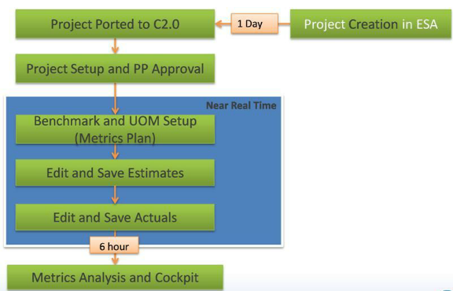
Viewing and editing of the Project details are done in Projects menu.
Project Setup holds all the basic details of a project like the project ID, start and end dates etc.
Resource management & Sub project creation are some of the other things that can be done here.
The four mandatory fields: Solution type ,Technology , Methodology and Project size Classifier has to be entered in project info page which will be main criteria to select the Process package for the project.
- Onsite and Offshore location details can be entered.
- Project execution and Project execution ration can be viewed here.
- Audit status can be mentioned here.
- IE factors can be set for the project. The expiry date can be set for IE factors in this page..
- Sub projects can be created or deleted from the main project.
- Once the project has tracking, sub projects cannot be created.
- System will automatically recommend a suitable process for the project based on Primary Technology, Methodology, Solution Type and Size.
- Customer specific process can be easily incorporated in the system by tailoring the process.
- Customer specific Templates, Guidance and Checklist can be attached to the existing process.
- Active Process Guidance will be made available in terms of Input , Output, Guidance's and Checklists for a task.
- It is possible to copy a process package which is created in the same account.
- If the system doesn’t recommend any process package, then check ‘All process packages’ and check the values (Technology, Methodology, Solution Type and Size) that the system expects . Change your project parameters accordingly in Project Setup.
- It is also possible to create a new process package from scratch.
- Process package can be selected from Recommended PP page. A PP can be copied only for the first time when the project is created.
- Worktypes can be selected if needed for the project from Configure Worktype menu.
- PD mapping can be viewed in PD mapping section in Edit PT master.
- Phase mapping will show the Phase mapping done for the phases at org level.
- Edit task menu has the details of the tasks in the PP where the task mapping, COQ mapping can be done.
- PP can be sent for approval in Work flow menu.
C2 →plan setup-::::---C2→home page→projetcts→Work setup→Plan setup
- C2 guides the project planning activity by inheriting the process to create a Work Breakdown Structure (WBS).
- This is done to ensure that process definition and project planning are not done in isolation. The WBS is created in the form of WMP (Work management plan).
- There is no limitation on the amount of WMP’s that can be created in a project. WMP’s may be created for a phase, process or for all phases.
WMP tracking in MPP
Steps to do Detailed Planning through MPP
- Navigate to C2 Home page->Support->Download and Install Pre-Req of MPP Plug in and C2.0 MPP Plug in.
- On the Cognizant 2.0 menu, go to Projects →Download WMP. Download Work Management Plan pop-up window appears, which enables you to download a WMP in Microsoft Project.
- Select the required WMP from the list of WMPs displayed and click on “Download WMP”
- Select the WMP on the left pane and click on ‘Download WMP’. On receiving a confirmation message ‘WMP details downloaded successfully‘ close the Download WMP window
- Select Cognizant 2.0→Projects →Choose WMP and select the WMP name →Import
- System will display the following message ‘Plan status may have changed outside the environment. The status will be updated before importing the plan”. Click ok
- When the system prompts the user to lock the plan and import, select “Yes”, this prevent s other s from Editing / Tracking the plan.
- Once the plan is downloaded, the following can be done

- Add a new task
- Modify the existing task
- Delete the existing task
- If a new task is added, map it to the existing Phase, Activity, PD and Task so that the metrics is captured for the new task
- All the tasks will be imported to the MPP along with the predecessors & the PM has to plan the effort , schedule and assign resources for the task
- Resource Assignment can be easily done by selecting Cognizant2.0 àWMP view àAssignment View
- System allows to modify the predecessors for the new task / existing task or rename the existing task
- Once planning is done, baseline the plan by using the following options (In MS Project 2007, Tools à Tracking à Set Baseline)
- Ensure base lining is done every time, i.e. after addition of new tasks and / or if there are any changes in the plan dates
- Once it is base lined, synchronize the plan by selecting Cognizant2.0 à Save / Synchronize àSynchronize
- On receiving the message ‘Project Synchronized Successfully’, and system prompts for Unlock. Unlock the plan by selecting Cognizant2.0 àProjects. Select the plan, right click and select unlock, and provide necessary comments. Plan gets unlocked and is ready for tracking.
Factal Task Creation
- Fractal task can be created by any member irrespective of the role.
- The resource who had created the fractal task can only Close/Cancel the task.
- The fractal task can be deleted if it is either in Unassigned/Assigned status.
- The tasks that are assigned to a resource can be viewed in the Task Tracking menu of the Work.
- Initially, the task will be in ‘Assigned’ status.
- The Assignee can change the status to ‘Start’ etc. as applicable.
- When the task is complete, the actual effort and the schedule details can be entered by the resource and set to ‘Completed’ status.
- If there are any mandatory checklists mapped to the tasks, then it should be completed before the task is set to ‘Completed’.
- The relevant artifacts/guidance mapped to the tasks can be viewed in the same screen at the bottom.
- Task can be set to ‘On Hold’ if required or Task can be reassigned to other resources.
C2 Tracking
- Task when assigned will be available in Task tracking page under Work->Tracking menu.
- Status available when a task is assigned to the resources.
- Task can be changed to Start, Re-assign and complete status from Assigned status.
- Actual start date can be selected from the Actual start field.
- By default, the actual start date will be the date when the task is assigned to the resource irrespective of the Planned start date.
- Actual efforts can be entered by clicking the Actual effort.
- Once the task is started, it can be changed to Hold, Reassign, Complete and Pause status.
- Mandatory checklist has to be updated when the task is completed.
- Guidance to complete the task is available in the Guidance tab.
- It provides the steps to perform to complete the task.
- It has Phase , Activity and Task Guidance.
- Artifacts will have Input and Output artifacts with the link which will take to the document/site where the work products are mentioned.
- Notes related to the task is mentioned in the Notes tab.
This slide shows the representation of C2 reports
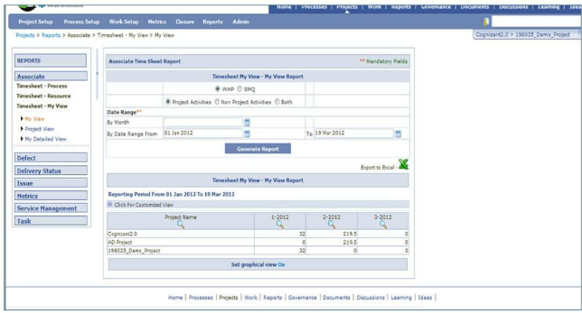
Metrics-Metrics Plan
- Metrics Plan can be created once process package is approved.
- There are some mandatory metrics that each project should report. Apart from that, there are also optional and additional metrics that a project can report depending on the need of the project.
- The goal values for the metrics plan are the standard OLBM/PLBM values based on the process package. The values can be overwritten providing necessary reasons.
- A resource with PM/PL role can create metrics plan.
- The metrics plan needs to be reviewed by Quality Reviewer/Quality Champion and then can be approved by PM.
Metrics plan can be created by Pl and above role.
Metrics plan once created, have to be sent to QC/QR for review.
Once reviewed it has to be approved by PM.
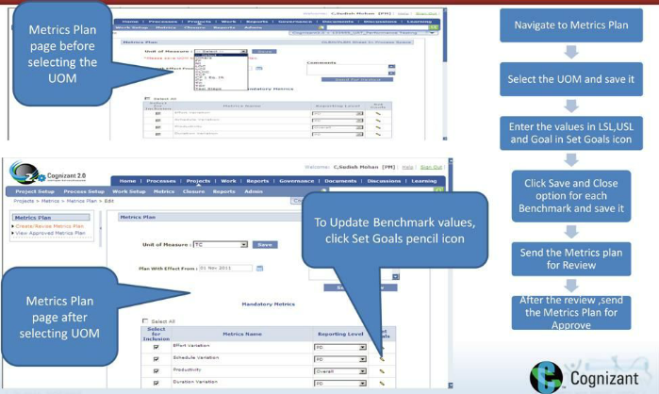
Metrices Estimated
- Need not wait for 1 hour to Push estimates and then edit estimates, same can be done near real time.
- Generate Estimate to pull the efforts and schedule from task tracking.
- Option to copy the last approved Estimates for the respective projects.
- Red book available next to each PD and how the efforts are rolled up can be viewed in detail.
- Removal of Metrics Role Selection pop-up
- No two scrolls – iFrame and IE scroll
- Create/Review and View Estimates are made a 2 separate screens for ease of use.
- Reload All PDs: Refreshes the screen to reload all the PDs applicable for the project as per the PP configuration.
- Configurable email notifications
Metrics Actual
- Removal of Metrics Role Selection pop-up
- Need not wait for 1 hour to Push Actual and then edit Actual , same can be done near real time.
- Generate Actual to pull the efforts ,schedule and defects from C2 tracking for the reporting period.
- Red book available next to each PD and how the efforts are rolled up can be viewed in detail.
- No two scrolls – iFrame and IE scroll
- Create/Review and View Estimates are made a 2 separate screens for ease of use.
- Metrics Analysis preview can be viewed real time once Actuals are saved.
- Reload All PDs: Refreshes the screen to reload all the PDs applicable for the project as per the PP configuration.
- Configurable email notifications
Metrics Analysis
- No two scrolls – iFrame and IE scroll
- Metrics Analysis can viewed after 6 hours after Metrics actual approval.
- Removal of Metrics Role Selection pop-up
- Productivity displayed in a separate table for usability as it is applicable only at overall level
Delete Metrics
- Delete Metrics applicable only for the selected project context. User need not select the project and do the necessary action.
- No two scrolls – iFrame and IE scroll
- Removal of Metrics Role Selection pop-up
- Easy to view the latest Metrics artifact and perform deletion
- Configurable email notifications
Defects
The Define Project Scope page enables to configure defect management (Defect as Work Type or DWT) or configurable issue management (Issue as Work Type or IWT), for a new project marked as a tracking project
Once the Check box is selected and saved, the project will start tracking the defect as work type module in their project..
By default process independent template will be selected for the DWT enabled projects
- This template is to capture the defects information without having dependency to the process attributes.
- Projects using this template can log defects without having process package
- User is allowed to tailor this template by raising service request
Note: Process Dependent template will be published by default allowing the user to create defects even without going to Setup screen.
We can create the test/review records for the defect from C2 home page.
Reporting source , Defect logger, Task mapping and PD mapping has to be selected while creating the Record.
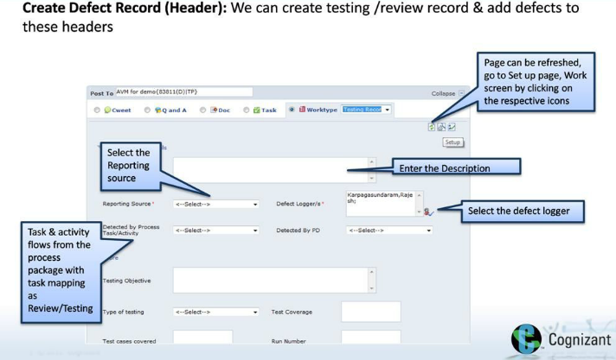
We can create the defect by selecting Defect fro Work type drop down.
Appraisal type, Title and Severity can be provided while creating the defects.
Test/Review record if created, can be mapped while creating the defects.
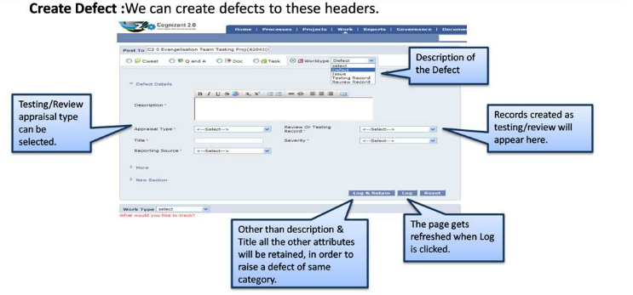
Tracking Defetcs
- Defects can be tracked in Track tab.
- Defects assigned can be viewed here.
- Status of the defect can be changed here to Fix in progress or Defect on Hold from Assigned status.
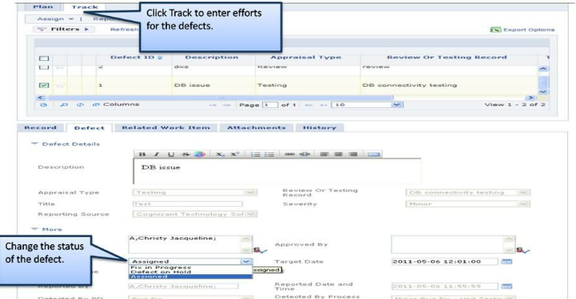
Social Collabration
Once the Is tracking is enabled, after 30 minutes, the project will be available in Documents under project repository.
The resources who are available in the project can access the project repository in Documents.
C2 documents
- To store project related documents in a repository.
- A project repository is auto created when the project is created in C2.
- Associate tags with a document for easy retrieval.
- A single document can be at a maximum size of 50MB.
- Available to all users.
- Versions are maintained. You can check out a document, make changes and check in.
C2 discussions: C2→ home page→ Discussions
- Discussions enables the project teams to have project discussions.
- Users can subscribe to the forums they want to a part of.
- This can be integrated with Outlook, it is possible to post and reply to the messages from Outlook
Testing Metrics Module-Prerequisite
- Solution Type should be ‘Testing’.
- Process Package should be ‘Testing – Full Ownership V2.1’ or ‘Testing – Full Ownership V3.0’.
- Process Package should be approved.
- Project should be a tracking level project (Leaf Level Project)
- Projects tracked at the main project level without any subprojects under it
- Projects tracked at the sub project level, that is there are one or more subprojects created under the Main project and tracking is done at the Sub project level. In such case each of the Sub project will have to be enabled for the Metrics Module.
- User should have PM/PL access for the tracking project
- Once the PP for the project has been approved, Testing Metrics enablement can be done only after 24hrs.Solution Type should be ‘Testing’.
- Process Package should be ‘Testing – Full Ownership V2.1’ or ‘Testing – Full Ownership V3.0’.
- Process Package should be approved.
- Project should be a tracking level project (Leaf Level Project)
- Projects tracked at the main project level without any subprojects under it
- Projects tracked at the sub project level, that is there are one or more subprojects created under the Main project and tracking is done at the Sub project level. In such case each of the Sub project will have to be enabled for the Metrics Module.
- User should have PM/PL access for the tracking project
- Once the PP for the project has been approved, Testing Metrics enablement can be done only after 24hrs.
Testing Metrics Module- Features
Access Level
Only PM & PL have access to the Testing Metrics Module.
Enabling Testing Metrics from front-end.
Option available in Metrics page under Projects menu of a tracking project.
Availability of Weekly & Monthly Metric Frequency.
One time selection of Metric Frequency - either weekly or monthly during Testing Metric enablement.
Metrics Setup
Metrics setup will provide the ability to view the details of all Standard, Calculated and Custom Metrics for the tracking project.
Metrics Benchmark Update
- Provision to capture UOM for the project. (UOM is an one time selection)
- Benchmarks is mandated for all metrics.
- Metrics Actual link would be visible only if benchmarks for all the metrics are updated.
- Provision to define Goal / USL / LSL for all metrics .
- Provision to Copy OLBM / PLBM values available.
Metrics Actuals
- Allows project data measures to be entered into C2 for computing Metrics.
- Based on selected UOM respective Measures are listed for data entry
- Provision to capture Target and Actual made available.
- Status of Measures entered can be viewed.
Testing Metrics Dashboard
- Allows associate to view the Testing Metrics Report along with graphical representation for past 6 weeks.
- Associate can View / Export all Metrics together along with graphs.
- Reporting Frequency is Weekly or Monthly.
For more details on Testing metrics access the below link:
https://cognizant20/cts/Cognizant%20Community/C19/C2%20User%20Community%206000000019/DS/C2%20User%20Community%206000000019/C2_Testing_Metrics_User_Manual.pptx

